Uniform & Badges

Everyone
The Group will provide the red Group scarf and all badges. All other items should be purchased prior to investiture.

All the badges on the right sleeve should be positioned below the embroidered Scouts logo. The Ware District and Hertfordshire County badges on the right sleeve should read ‘District’ then ‘County’ from left to right.

Beaver Scout Uniform
Beavers should have a full uniform of turquoise Beaver Scout sweatshirt and a Group scarf and woggle. Optional uniform items for Beaver Scouts include the blue activity trousers, turquoise polo shirt, blue activity shorts and a Scouts baseball cap.

Cub Scout Uniform
Cubs should have a full uniform of green Cub Scout sweatshirt and the Group scarf and woggle. Optional uniform items for Cub Scouts include the blue activity trousers green polo shirt, blue activity shorts and a Scouts baseball cap.

Scout Uniform
Scouts should have a full uniform of teal Scout shirt, blue Scout activity trousers with Scout belt and the Group scarf and woggle. Optional uniform items for Scouts include the teal polo shirt, blue activity shorts and a Scouts baseball cap.

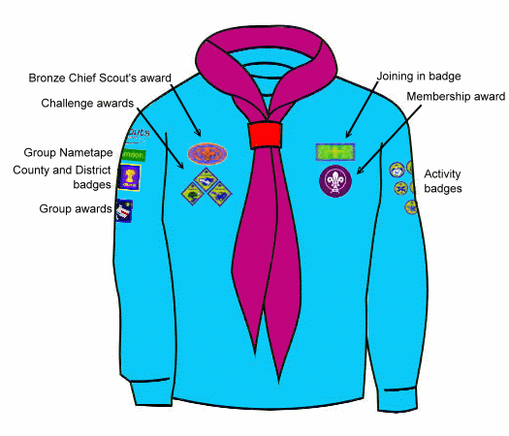

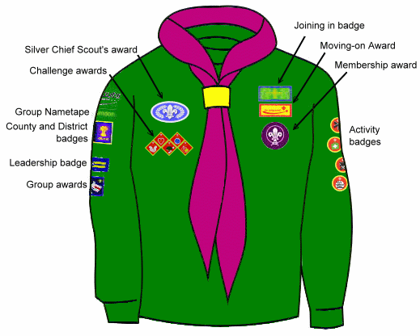

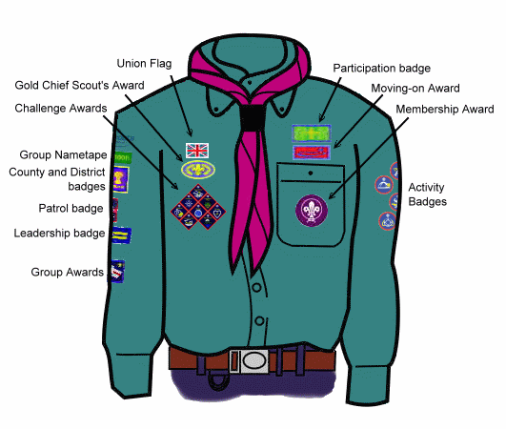

Where to buy?
All uniform may be purchased from:
Ware & District Scout Shop Agency
District Headquarters
Broadmeads
Ware
Herts SG12 9HS

Opening Times: Tuesdays 7.30 p.m. to 9.00 p.m.
(School term time only)

Cash & cheques only; sorry, no credit or debit cards.

This agency is run by volunteers and the profits used for the benefit of Scouting in the Ware & District area, thereby helping to keep your membership subscriptions down. Please avoid purchasing from other commercially run outlets.

