Monday Scout Troop

The Monday troop was setup in November 2010 with one Scout transfer, one Cub and one ex-Brownie. I am pleased to say that six months later we have increased the number of Scouts to nine with two patrols.  I expect the troop numbers to expand to fifteen by the end of 2011, helped in part by the “Bring a Friend” scheme started in February. |  | 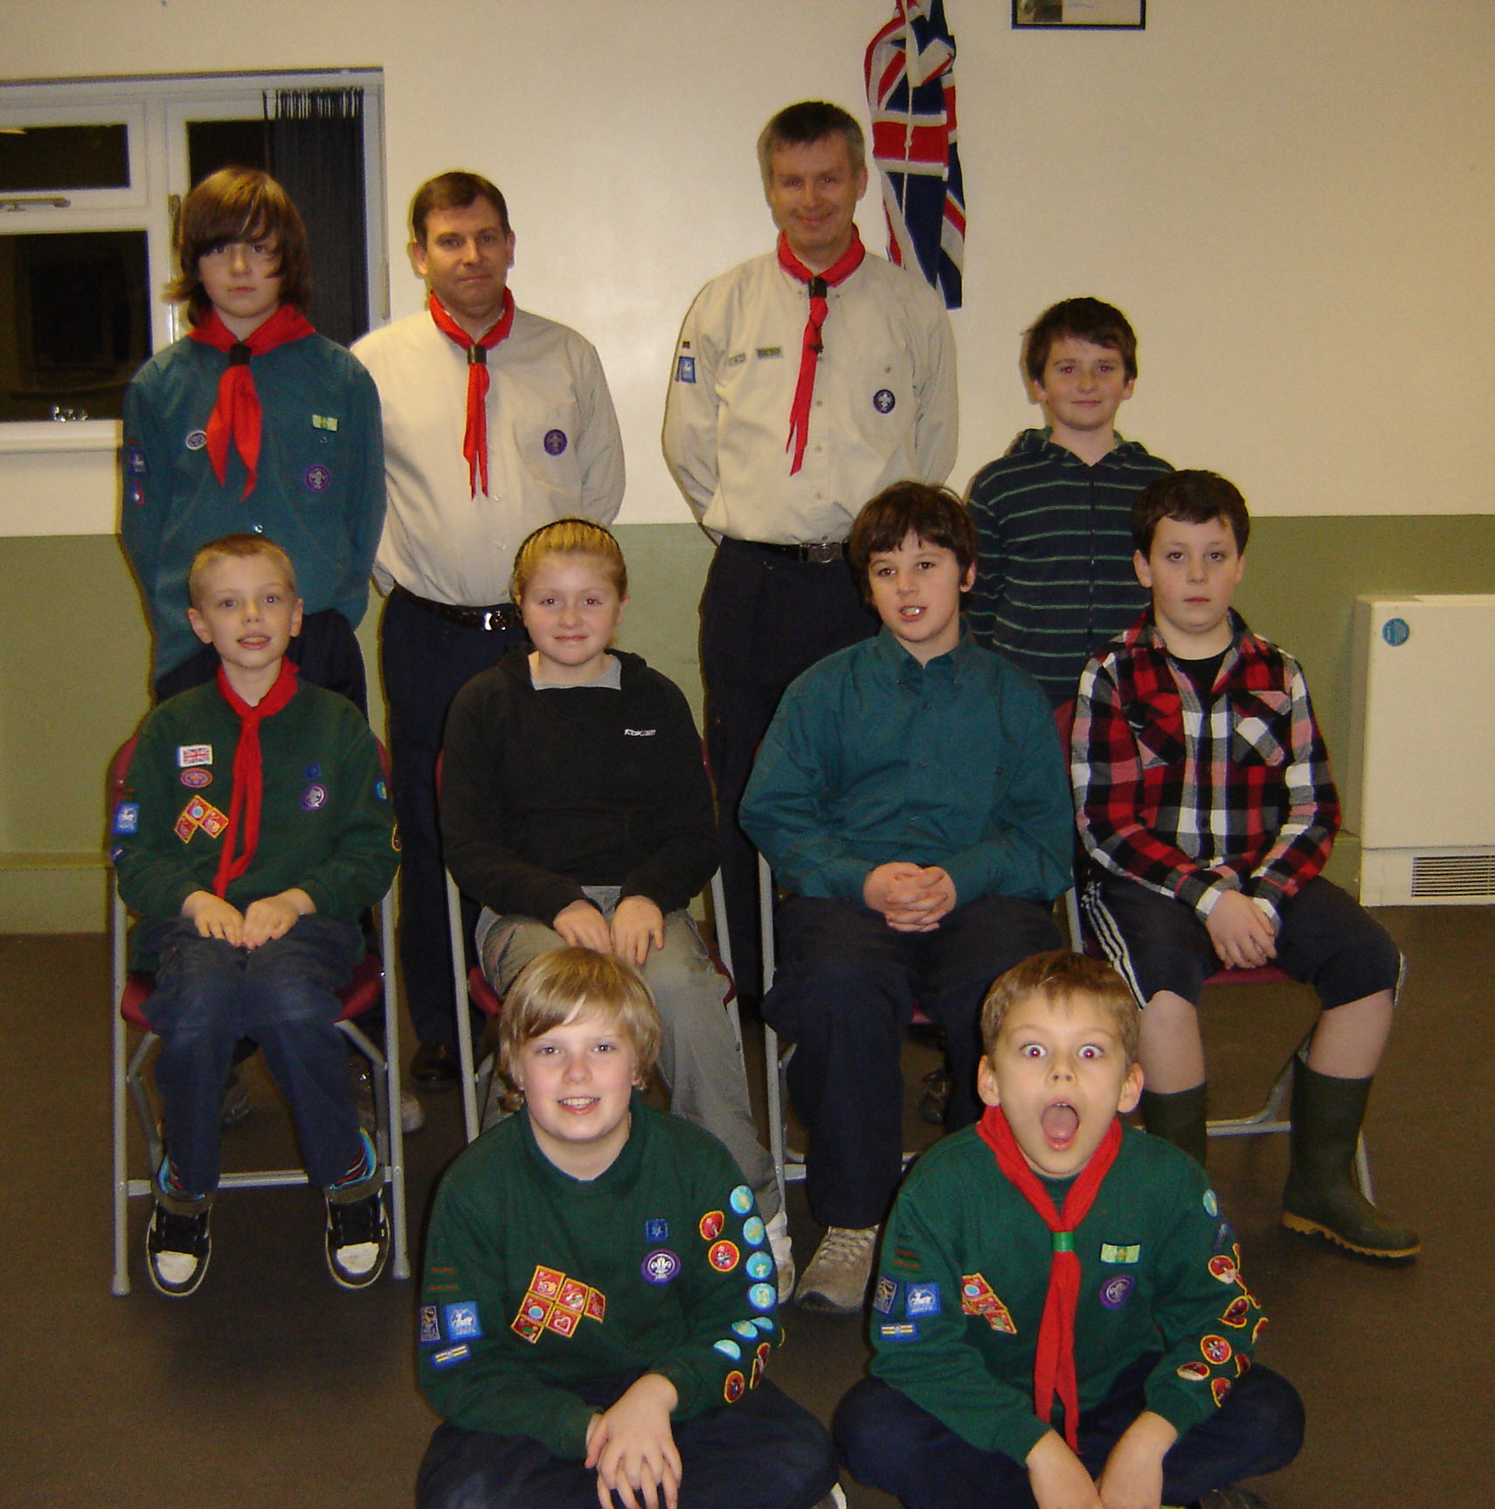
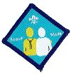 | This scheme first used in Kent encourages Scouts to introduce their friends to Scouting and mentor them through to investiture.  Two Scouts are scheduled to complete their work this term when they are expected to qualify for the Scout Mate Badge.

The Troops first memorable Investitures took place around our Camp fire on a cold December evening. Popular with both Scouts and Parents, I am hoping to continue with the outdoor themed Investitures in the coming years.

Last term we arranged a visit from the Hertford Police to help Scouts work towards their Police – Community Challenge Award. Three Scouts have successfully completed the award and will be presented with their badges in the next few weeks.

Although this is a young troop, the Scouts have enthusiastically participated in several local events, coming 6th out of ten at the District Cooking Competition. This term the troop is keen to enter more District events, such as, the Outdoor Bowls, Swimming Gala, Raft Race and the Centenary Camp. Scouts are also working towards their Chef Activity Badge and Expedition Challenge, which they expect to complete before the summer break.

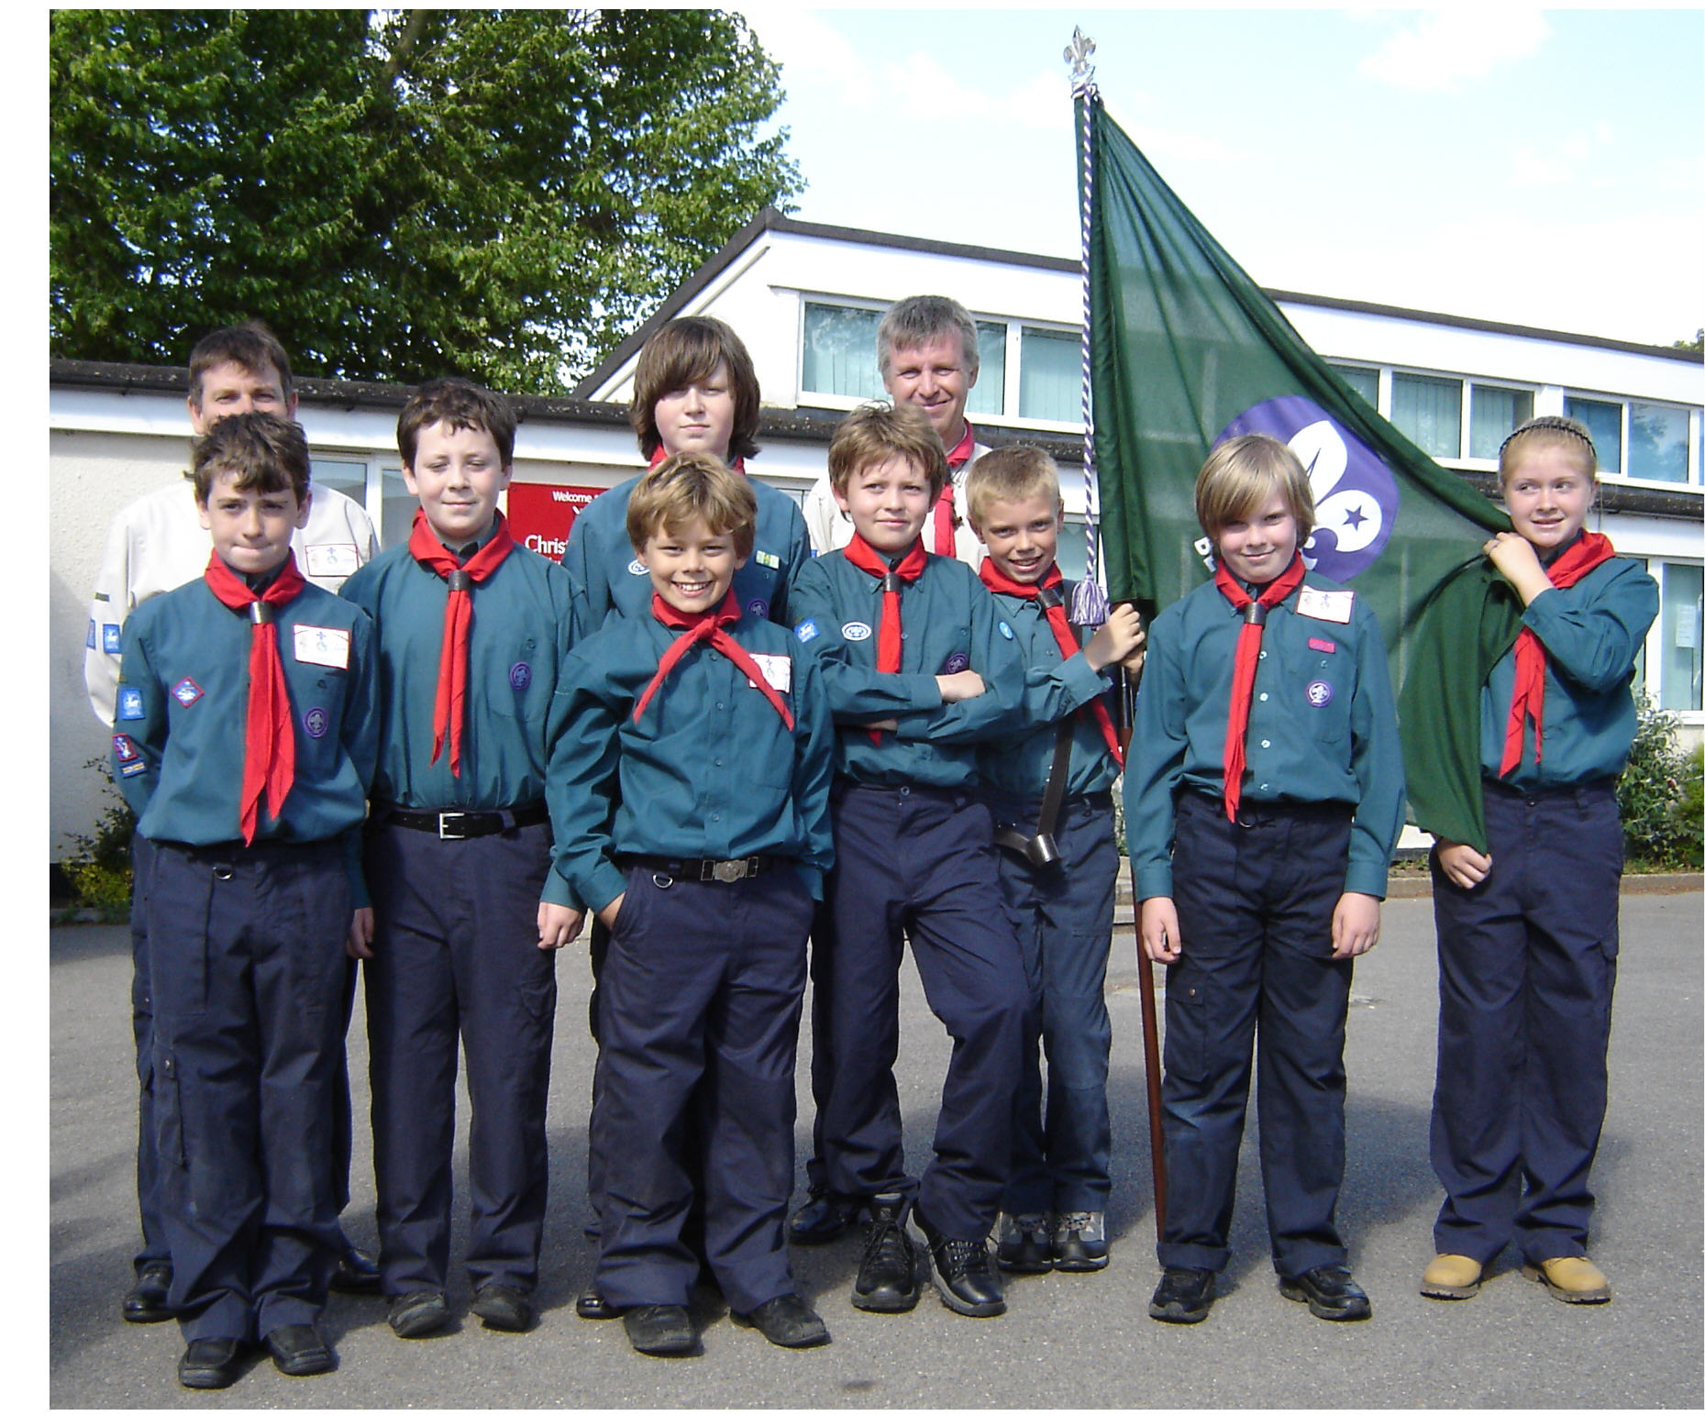 | We represented Great Amwell at St Georges Day, and as part of their Community Service the Scouts assisted the “Ware in Bloom” team to prepare the 100 hanging baskets.  The St George’s day photo shows a confident new Troop that have progressed and matured over the last 6 months. They are a credit to Great Amwell and their leaders.
Finally I would like to thank the leaders, Ian Devonshire, Bob Johnson, Rebecca Johnson, Jonny Dillon (YL), Darrell Johnson (YL) for their time and efforts in helping to create the very successful Monday Troop.

Anthony Dakin - SL

