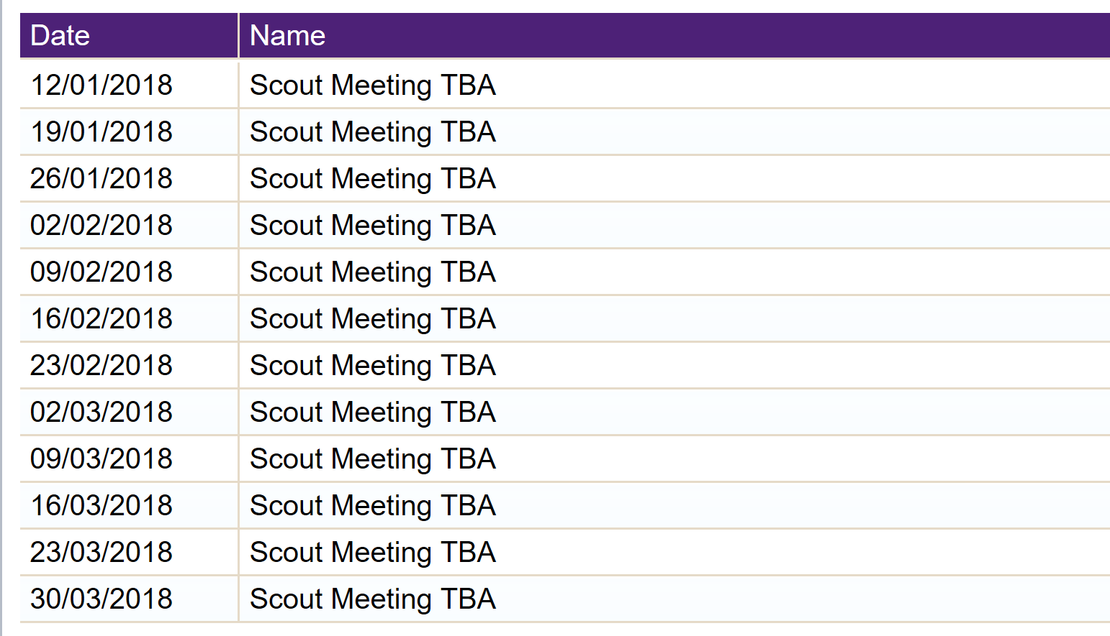

http://www.greatamwellscouts.com

