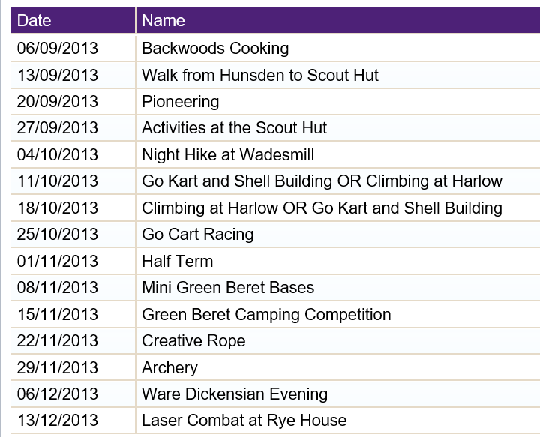

http://www.greatamwellscouts.com/

